### PYTHON DICTIONARY PROBLEM STATEMENT

### 1.Delete a list of keys from a dictionary

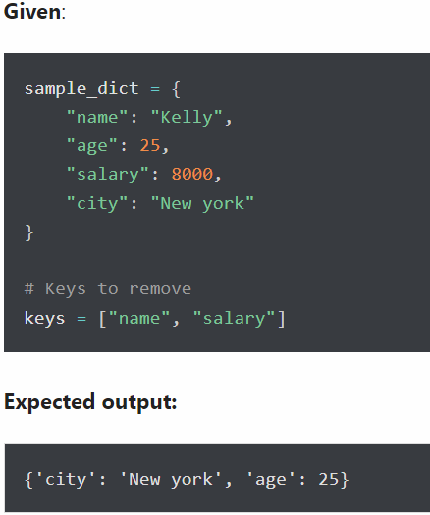

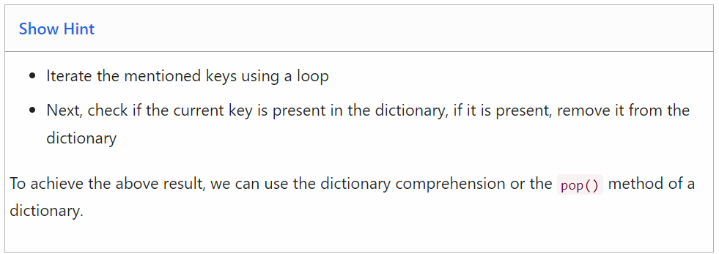

### Code: sample_dict = {"name": "Kelly","age": 25,"salary": 8000,"city": "New york"}

### keys = ["name", "salary"]

### for k in keys:

### sample_dict.pop(k)

### print(sample_dict)

**Output:** {'age': 25, 'city': 'New york'}

**2. Check if a value exists in a dictionary**

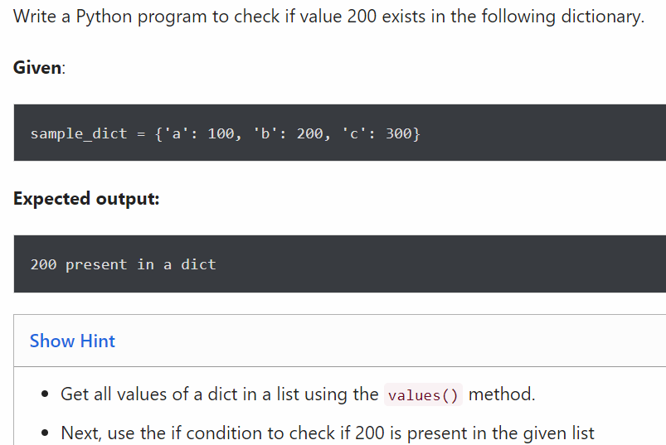

**Code:** sample_dict = {"a": 100, "b": 200, "c": 300}

if 200 in sample_dict.values():

print("200 present in a dict")

**Output:** 200 present in a dict

**3.Rename key of a dictionary**

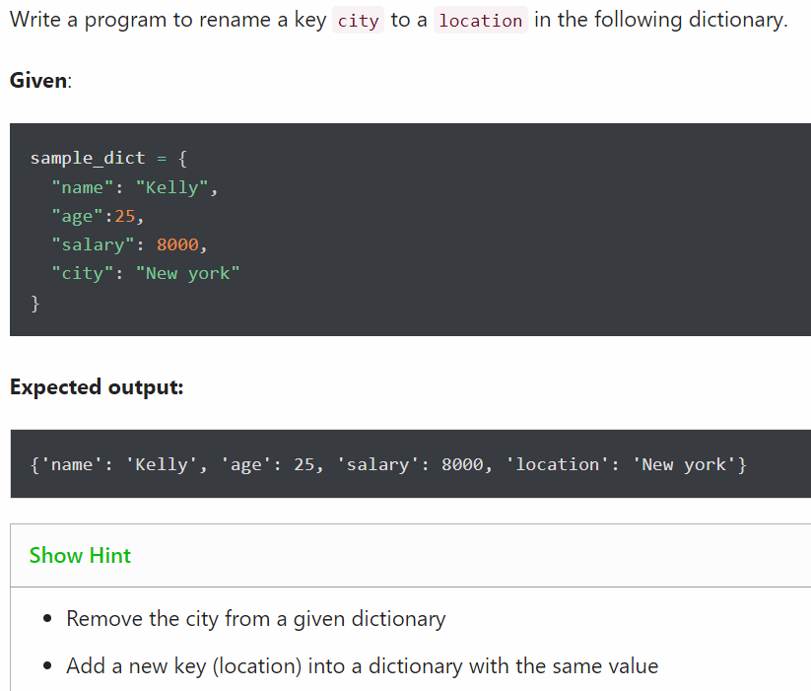

**Code:** sample_dict = {"name": "Kelly","age": 25,"salary": 8000,"city": "New york"}

sample_dict['location'] = sample_dict.pop('city')

print(sample_dict)

**Ouput:**{'name': 'Kelly','age': 25,'salary': 8000,'location': 'New york'}

### 4. Get the key of a minimum value from the following dictionary

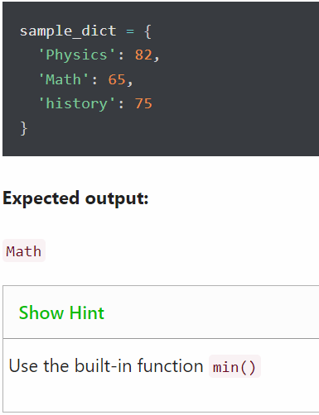

**Code:** sample_dict = {"Physics": 82,"Math": 65,"history": 75}

print(min(sample_dict))

**Output:** Math

### 5.Change value of a key in a nested dictionary

Write a Python program to change Brad’s salary to 8500 in the following dictionary.

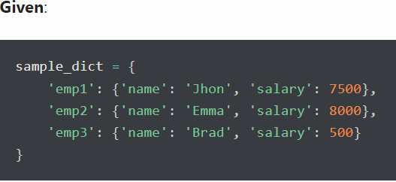

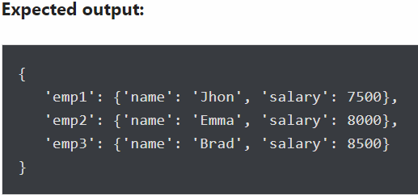

**Code:** sample_dict = {

"emp1":{"name":"Jhon","salary": 7500},

"emp2":{"name":"Emma","salary":8000},

"emp3":{"name":"Brad","salary":6500}}

sample_dict["emp3"]["salary"] = 8500

print(sample_dict)

**Output:** {'emp1': {'name': 'Jhon', 'salary': 7500},

'emp2': {'name': 'Emma', 'salary': 8000},

'emp3': {'name': 'Brad', 'salary': 8500}}

**6.**



**Code:** name_dictionary1={"first_name":"John","last_name":"paul"}

name_dictionary2={"first_name":"Virat","last_name":"kohil"}

print(name_dictionary1)

print(name_dictionary2)

**Output:** {'first_name': 'John', 'last_name': 'paul'}

{'first_name': 'Virat', 'last_name': 'kohil'}